Software development 2
Coursework assessment
Owusu-Amankrah, Natasha 2- 3224849

Table of Contents
Executive summary 3
Introduction 3
Screen grabs 3
There were three parts to this coursework which consisted of; plain command line, using objects, GUI and tests. The purpose of the command line section is to allow the user to see all the answers as it should be to each file 3
Testing strategy 7
Unit testing 7
Report 7
Executive Summary 7
Introduction 7
Findings 7
Applying it to python GUI 8
Evaluation 10
Disadvantages 10
Strengths 10
Bibliography 11

Executive summary

In this report I have been asked to produce a program in which should be commented and tested for approval. The program should also have three different parts, the structured programming, classes and GUI.

Introduction
In order to show evidence of work produced, the work must be annotated with understand and copies of the work must be shown in the report. The report must include an explanation of what GUI is and what their good practices are. It must also include

Screen grabs

There were three parts to this coursework which consisted of; plain command line, using objects, GUI and tests. The purpose of the command line section is to allow the user to see all the answers as it should be to each file, to check that all answers are the same.
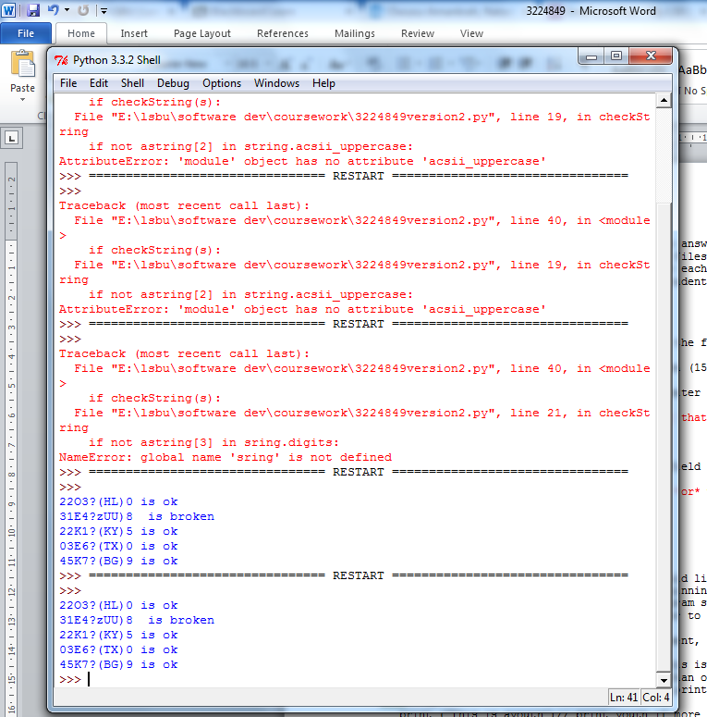
I was able to achieve this..
After several attempts and incorrect spelling of string and comments out of loops

The code above runs the first five lines in the file and tests which lines are okay and are broken, from the result it shows that two lines are broken from the file. The screen grab shows a clearer result. These tests are for the first part of the program which is structured programming. Although this wasn’t required I decided to run a program which enabled me to see which

This answer is to show how many lines in the fields are invalid. This happens to be 2 lines in the field.

Format strings verify whether the

The user has the option of choosing which file they would like to display.
Functions: This allows easier interaction with the user

Once the file has been opened the program responds with the following results to the following seven questions.
File 3224849b
The next part of assignment is based on object oriented programming where the structured programming is structured with class objects. The first is the class counter, demonstrator, filereader and a class function that opens each file at once.

Testing strategy

Unit testing
Unit testing allows the tester to check each class of the program to check if all of the codes are working and not just running. There will be pictorial evidence in doing so; this will allow the developer to view what the program should look like.

Report research question
- Using Graphical User Interfaces – What is Good Practice?. What guidelines can you find about good use of colour, Text and Positioning in a GUI. Try to look at a number of sources. Keywords: GUI, color colour, Text, Positioning, good practice, Assistive technologies.

Executive Summary

The purpose of this report is to research and gather information about Good practice when using GUI also known as Graphic User Interfaces. Graphic user Interfaces are used to enable users to interact with electronic devices through the interface. Below you will find a more detailed document of the good practices GUI follows and what examples of sources that display good use of colour, text and positioning in a GUI.

Introduction

Graphic user Interface allows increased productivity. The attractiveness of the system needs to be considered. Last but not least how the users can accomplish work on computers using images in text the purpose of this report is to research and gather information about Good practice when using GUI also known as Graphic User Interfaces. Graphic user Interfaces are used to enable users to interact with electronic devices through the interface. Below you will find a more detailed document of the good practices GUI follows and what examples of sources that display good use of colour, text and positioning in a GUI.
At times it is essential to use assistive technologies. Assistive technology allows control and independence to users who struggle to complete everyday tasks like turning on lights, making phone calls, using the internet.

Findings
Good user accessibility entails a good layout, and clear and reasonable sized font. A few combo boxes and command buttons positioned in the appropriate places on the page would be idea also. Users who have little knowledge of computers will find it easy to navigate around the system. Here is an example of a code showing combo boxes in the program.

The purpose of a good user accessibility isn’t just of users with disabilities it is also for users to have an ease of being able to use the page. For example if the background is white and the font colour is black the user will find it easy to view the interface. Accessibility must consider where the user is accessing the interface from, for example the interface must be adaptable to Tablet devices and mobile devices.

Applying it to python GUI
This changes the font it is to be size 12 for the whole of the interface. This is a suitable font size for good readability.

Font=12

If there is a combo box with all the files inside the box, the user can select their preferred file to open. The user will also be able to use the command button to close the interface. In order to create

Previously experiencing the development of GUI in the language python, I learnt about the colour of the display, I also learnt about the font type and colour and combo boxes. I will be adding this to my program to show my understanding and how I have applied it to my own. The classes would have to be changed as the current classes will not run with the combo boxes.

The background for the answers will be white with the font black as this helps is known as one of the safe colours to view on the web.
Bg= white
Overall it is better to have an interface in general as this allows the user to view the program easily
My EVIDENCE GUI

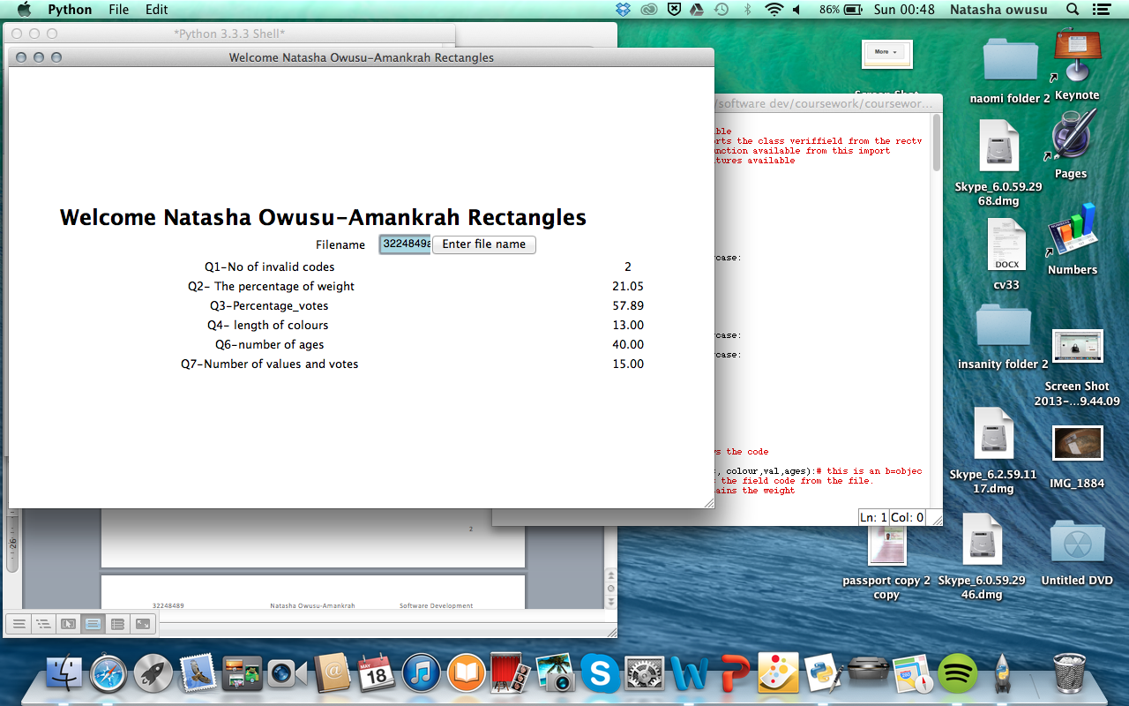

Evaluation
This semester I was commissioned to produce a program which allowed the user to extract information from the files given. We spent 13 weeks compiling a group of parts together to show understanding in different ways in the program.
In this assessment I was asked to produce program with the three files given. The files were to be used to answer the seven questions given in three different parts. The first part was known as structured programming. The structured programming also known as modular programming, is a basic version of the program, this involves the functions as well. This file is to show one file at once. This can be done by entering the filename and the extension at the end.
The second part of the program is the classes; this will include the counters, the class where all the counts for each question will be placed. I will also include the’ veriffield’ which will include the name of the fields which will be called into the program.

Disadvantages
There were many disadvantages in this report as I had to thoroughly understand the classes section in my program. I felt that I couldn’t understand the number of invalid codes; I had to understand how to get the right information from the right position of the file. When I had completed my programs. I decided to run all three programs to compare answers. I found out that, that was the beginning of my problems as my classes and my structured answers were different. I learnt that the program I had used in the first part were different to the classes so I had to change the classes to match my original code. After this I had to change my indent in order to change the answers.

Strengths
My strengths were in the designing of the GUI, I wish I would have more time to properly plan my design and include a lot more features than I did get the chance to. For example in the future I would make sure that my file with the combo box features would work. I was able to add the combo box feature but I needed to change the way my classes were, perhaps if I had had more time I would have been able to succeed in it well. In the future I would also like to add a text box, so my questions would be in a separate box to my answer field.
As a module in general, I have enjoyed the module as a whole, as it may have been challenging most of the times, but I was always grateful whenever I got the answers right. Although this is the end, I will look into learning even more about python so it will enable me to find the learning of other languages less challenging.

Bibliography
Computer hope(2013)-available at: http://www.computerhope.com/issues/ch000619.htm [accessed at 04/05/2014]

JICSC Digital media(2014)-available at: http://www.jiscdigitalmedia.ac.uk/guide/graphical-user-interface-design-developing-usable-and-accessible-collection#gui6 [accessed at 03/05/2014]

